Victoria Hall, Ealing: history and extent

Original concept and objectives

A report for Friends of the Victoria Hall

Introduction
The idea for a public hall belonging to the local Ealing community for their recreational use was conceived in 1886 by Charles Jones, Ealing's first architect, engineer and surveyor. Its origins and early history are recorded in his 1904 book.
Jones notes that, following the start of building a new Town Hall for the Council: “One great desideratum for a growing district like Ealing, viz a public assembly room, was wanting...The happy thought occurred to me that a permanent benefit to the poor might be associated with a Jubilee Hall, and be a perpetual memorial of our beloved Queen.”
He put the idea to the Chairman of the Ealing Local Board, Edward Montague Nelson, who agreed “with alacrity”. A report in the Middlesex County Times of Saturday 29 January 1887 records that, at a public meeting in the previous week, the project was launched to what the paper reported as enthusiastic applause. By the close, a small independent committee to manage a scheme for a separate structure had been approved. This was to be built adjacent to the still incomplete Town Hall, which had been begun the previous year.
The consent of the Local Government Board had been obtained to the plan, and with its approval, a piece of surplus land to the north of the planned Town Hall was allocated for the hall. This was subject to the proviso that the land should be retained by the Local Board and their successors, and that the Local Board would not be able to expend any money derived from rates on the maintenance of the Hall.
Initial Funding
It was made clear from the start that no public money was to be involved in the project. While the Town Hall itself was being paid for largely from the sale of the old building, the Memorial Hall, as it was then called, would be paid for by public subscription. An initial sum of nearly £2,000 had already been raised at the time of the public launch, and more subscriptions promised.
Mr Montague Nelson, who chaired the 1887 public meeting, said as part of his address: “It is fair to assume that from a hall which is to be built in this way by public subscriptions, on which there is no interest to pay on capital, there will be an income over and above its working expenses [which] should he vested in the existing Local Board, for the time being, as Trustee and devoted by them to local objects….We might grant a substantial sum annually to, say, the Cottage Hospital and the Almshouses, to the School of Science and Art of which we have one; or a grant to the Free Library.”
The scheme quickly took off. “Although the whole of the £5,000 for the hall was not obtained at once, a proposal to raise the balance by debentures of £10 each, repayable out of the profits without interest, soon cleared off the remaining debt, and left the memorial hall free as a charitable bequest for ever,” notes Jones.
Original extent
The original design was for a high main hall at first floor level with smaller rooms at ground and basement level beneath. It allowed for the installation of an organ at the east end with the rose window visible behind, as shown in Jones’ own drawing of 1888 (fig 1). As Jones notes this had not been fully achieved by the official opening: “The only regret we have is that the organ, as shown in the original design, was not carried out: £500 still remains at deposit for this object, and some day we may hope to see it accomplished, when Ealing will take its place, as it should have done years ago, as a first-class musical suburb.”
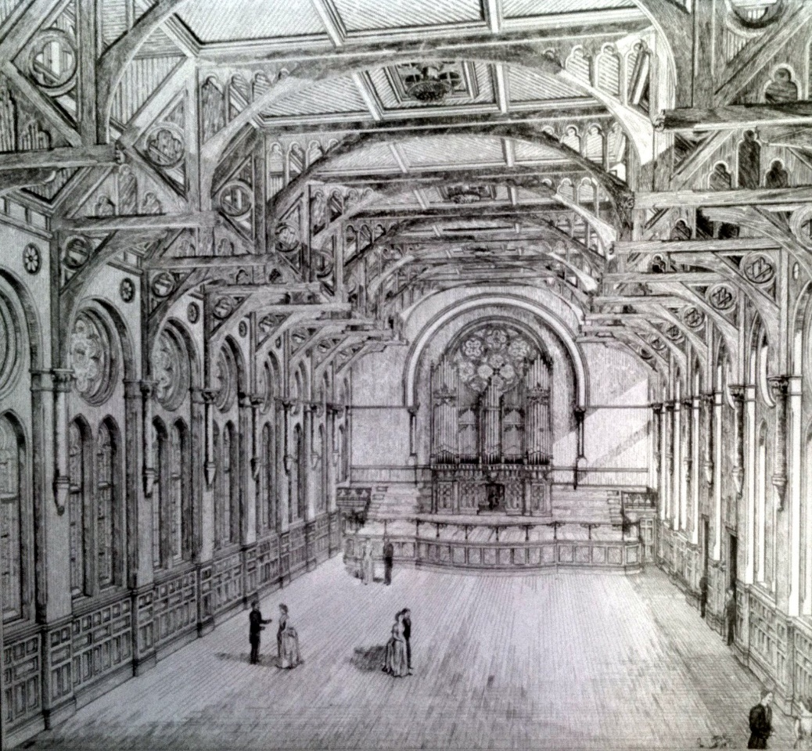

Fig 1: Drawing by Charles Jones of the original design (1888)
The structure stood attached to but separate from the main Town Hall apart from the first floor entrance to the Victoria Hall, which was accessed by a grand staircase through the main building. The Princes Halls below had their own entrance to the west, and the two buildings shared a common service staircase at the southwest corner. An ‘area' or void to the south acted as a light well to the rooms at ground and basement levels. (Fig 2)
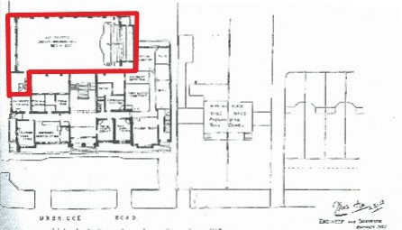
Fig 2: Charles Jones’ 1902 ground plan, Victoria Hall marked in red.
The final Trust Deed was not signed until 6 November 1893, but after the first few years, the Trustees felt that more should be done “in accordance with the original ideas [and] in order to complete the scheme proposed in 1887”. It was agreed to pay off the original loans and raise new money through further public subscription and the issue of debentures. It was also resolved to fund the purchase of an organ. In 1897/98 a covered way to the Princes Hall was installed. Stairs led to the Victoria Hall and to a platform at the west end of the Hall.
In 1899 the Trustees wanted more space This involved an “extension on the north side the whole length of the building, giving a Lounge, Smoking rooms and Buffet and an additional Dressing Room.” In the Princes Room, space was made for an extra cloak or store room at the west end, with an extension of the lower floor lounge “leading from the present room behind the platform, with a Smoking Room, Buffet and Caterers Room.” Approved in 1902, this included toilets on the lower ground floor. The lounge was built to smaller dimensions, but the whole area was ready in 1904. The Trustees also made a contribution to a portico to the front entrance of the Town Hall. This and the separate covered entrance to the Princes Hall can be seen in a photograph (fig 3) taken before the 1930s extension.
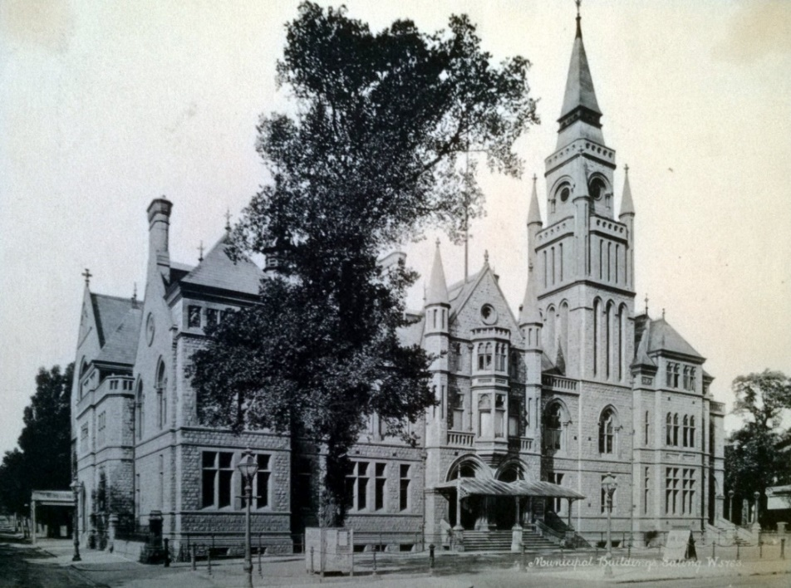

Fig 3 Town Hall frontage showing separate ground level entrances
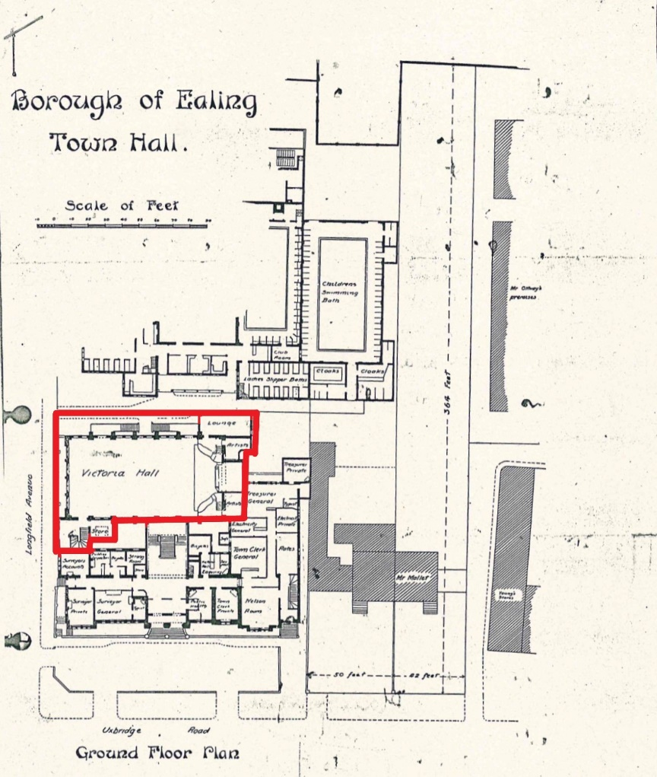
Charles Jones’ 1912 plans (figs 4 & 5) show the extent of this space at Victoria Hall floor level (which he calls ‘ground’), as well as the increased provision in the Princes Hall.

Fig 4. Extract from Charles Jones’ 1912 drawing (ground floor)
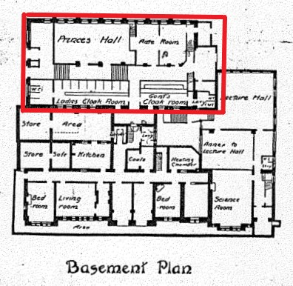

Fig 5. Extract from Charles Jones’ 1912 drawing (basement)
The OS map of 1915 (fig 6) shows the footprint of the Victoria Hall, marked as a separate building, after it was extended at the northeast corner. The only significant alteration after that date was the infilling of the open ‘area’ noted in the 1912 plan in the basement to the south, which had been a light well to the Princes Hall. This was used to create a kitchen for the hall with a storeroom beneath the stairs at the south-west, as in the 1934 plan (Fig 8). This footprint remained unaltered in the 1934 map (Fig 7), after the main east extension. The red lines denote the extent of the combined building area before the new wing.
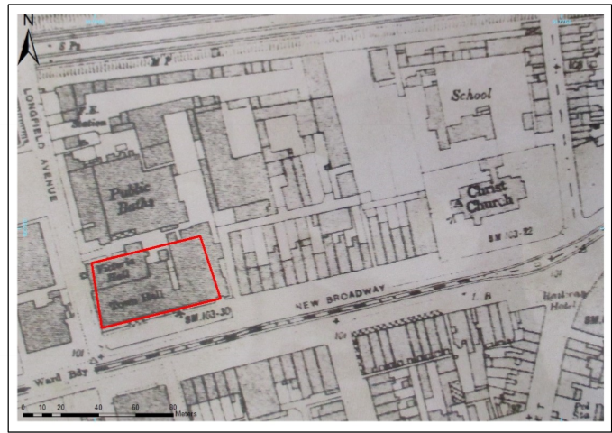
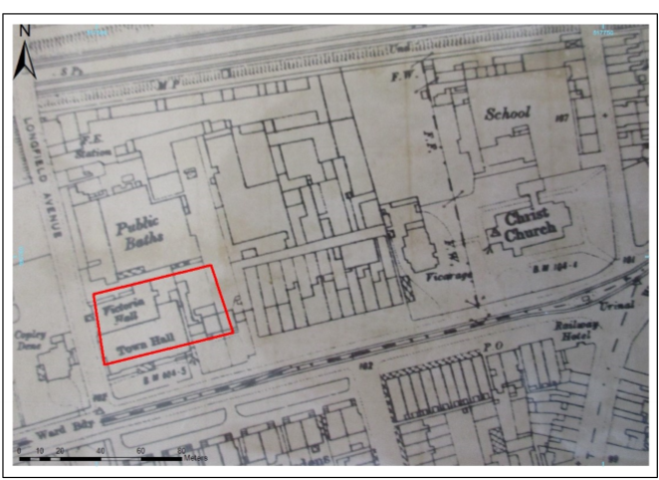
Fig 6. Ordnance Survey map 1915 (extract) Fig 7. Ordnance Survey map 1934 (extract)
The Borough Surveyor’s 1934 plan (fig 8) confirms that the Trust area was still considered not to be part of the general operational areas of the Council, despite the fact that its control had been passed to a joint Management Committee for the whole of the Town Hall.
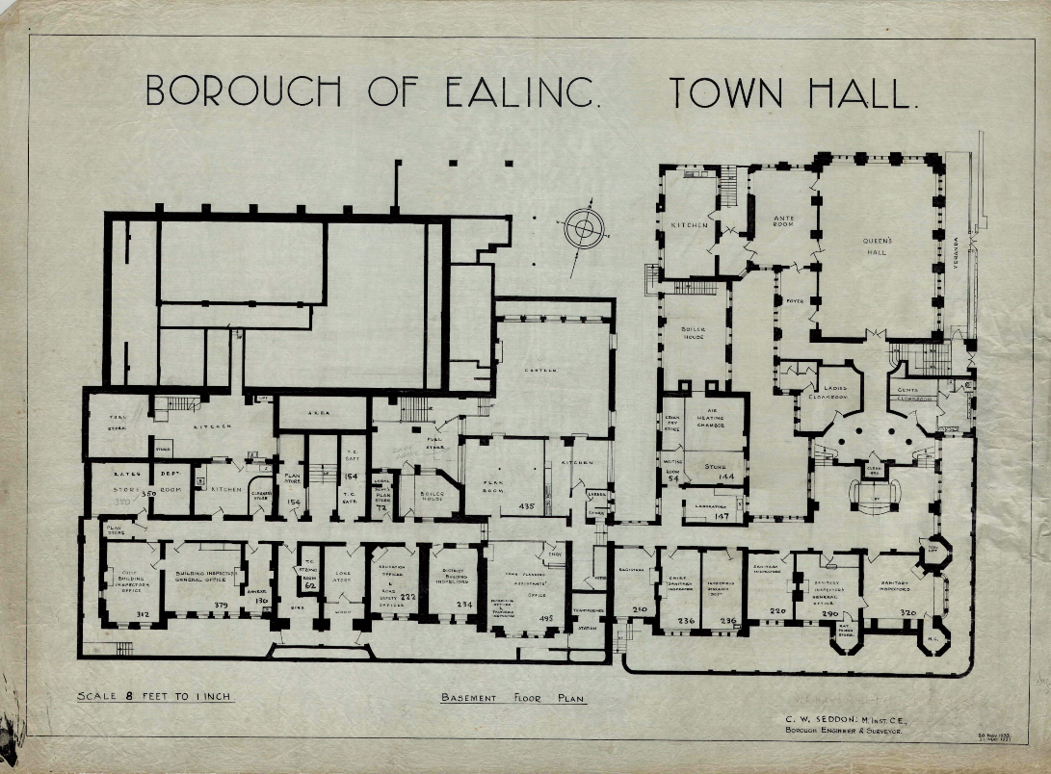

Fig.8 Borough Surveyor’s Town Hall plan (basement), 1934

Later changes
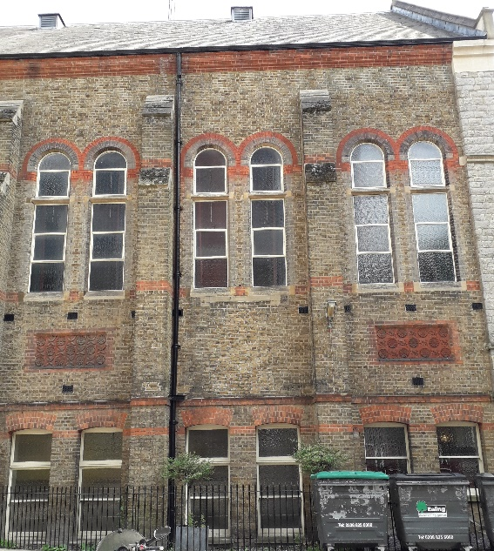
After 1912, no significant changes were made to the exterior extent of the building, but in the 1920s and 1930s several alterations were made to the interior. The platform inside the Victoria Hall at the west end, which had been accessed from the internal staircase at the south west, was removed. The external stairs to the second west bay on the north side were also removed, which led to the closure of the access through the bay, as can be seen today in the slightly different brickwork and the original lintel still in place (fig 9).
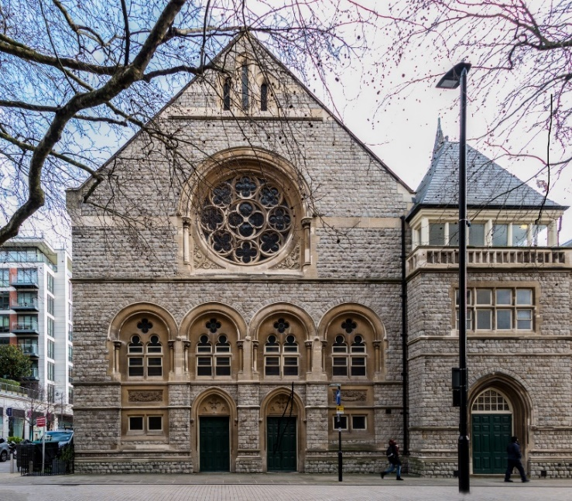
Fig 9. Victoria Hall north aspect Fig 10. Victoria Hall west aspect, showing access doors
At around the same time the 1898 external covered way was removed; other than the original doors, no trace of this remains. Public access to the Princes Hall and their related spaces became mainly through stairs below the main internal staircase to the Victoria Hall.
In 1957, the organ, which had lain unused for some time, was finally dismantled and sold. This allowed space to simplify the stage, which has previously been on two levels. By moving back the proscenium arch, the floor space of the Hall was also enlarged.
In the 1960s a modernisation of both halls took place, with false ceiling panels and contemporary lighting. The Princes Hall was converted into a tea room and was used as a staff canteen with access directly onto the street. The canteen was closed after the opening of the new Council offices in Perceval House in 1975. Since then the doors directly onto the street at the west have been kept principally for service access and as an emergency exit (fig 10), though have still been used for a public entrance on occasions such as for a mass vaccination programme and for vote counting at elections.
In 2009, reorganisation of the Princes Hall and kitchen was undertaken. At the same time, further work was done to improve the backstage access in the Victoria Hall, and the 1960s ceilings and ‘contemporary’ lighting were removed.
Since 2009 no significant changes have taken place in the extent or external appearance of the Trust property, beyond replacement in 2014 of the external staircase which now acts as a fire escape.

Uses, management and finances
At the outset, the building was well used by a wide variety of local organisations. The Trustees, who kept themselves strictly separate from the Council itself, were concerned to ensure that the halls should provide a full range of facilities to respond to this demand. At the same time they interpreted strictly the original secondary objective that “the proceeds derived from the hall should be devoted to the benefit of charitable institutions in the district”.No functions were permitted where the profits were not directed to charity.
These profits soon began to accumulate and by 1897 arrangements were being made to repay the earlier loans as well as making regular donations to local bodies such as the Convalescent Homes and Ealing Cottage Hospital. The Trustees also committed themselves to set aside funds for the payment of small pensions to the occupants of the Almshouses.
These arrangements continued for some years, but by the 1930s the pattern of demand for the halls had changed as other recreational opportunities such as the cinema appeared. Income was no longer sufficient to meet all the commitments that had been undertaken. Consequently in 1936 it was decided to merge the administration of the Halls under a Victoria Hall and Public Buildings Committee. In 1937 the Council took on responsibility for management and payment of the pensions in exchange for a fixed annual fee or “rent“ of £250, with all income from the Hall lettings going to the Council‘s General Rate Fund. Out of the rent it received the Trust undertook to provide for repairs, and running costs of the Coronation Cottages, charitable housing for retired long-service Council employees.
By 1948 the last of the original pensioners had died and the Trust fund was in surplus, but in the following years its fixed income was insufficient to meet its commitment to maintain Coronation Cottages. At the end of 1955 the balance was totally depleted and the Trust was operating at a nominal loss. To correct this, the Council’s annual rent was increased to £500, while hiring charges for use of the Halls were also raised, still going to the Council account.
In the same year, it was decided to sell the organ, which had fallen into disrepair. The sale was completed in 1957 and it was proposed that the proceeds should be used to build a new exit from the stage, but in 1958 the Charity Commission advised that the money should be distributed to local charities and one-off payments were made to several local bodies.
Rent of the Halls was increased to £700 in 1960 and again in 1966/67 to £900, to enable the Trust account to continue to meet the increasing cost of its obligations to support the Coronation Cottages. Management of the Trust concentrated on controlling the lettings for this purpose, with powers concerning the rents delegated to the Housing Committee.
In 1966 the Council was advised that the Trust should be registered under the Charities Act 1960. An application was prepared, which stated the objects of the Trust to be that “income [is] to be divided between and among and charities or charitable institutions in the District of the Local Board as the Trustees may think fit”. This appears never to have been submitted, and the Commission did not follow up its request for the Trust to be registered, but it seems that at the time the Council as Trustee did not see the primary object of the Trust as being the provision of space for hire by local people. After that, despite a legal ruling in 1935 that the Trust existed as a separate charitable entity, revenues from letting the Halls continued to be absorbed into the Council’s own accounts.
Pricing. From the outset the Trust fixed hire charges for the Halls with no reference to the market. This continued after the Committee handed over its responsibility to the Council’s Town Hall management right up to 2008, when a Hospitality and Events team was formed to operate all the Council’s lettable properties, including the Victoria Hall. In 2014, as noted in a Scrutiny Panel report a new Lettings and Pricing Policy was introduced in which a key decision was that “the major driver was ensuring that market comparable rates were charged”. This included a Community Rate Policy whereby all community groups were charged the same, with a discount of about 40%.
Over recent years, local hirings have been for uses ranging from concerts, dance groups, political and other society meetings to religious services. The Council has also used both areas for its purposes, such as election counts, public inquiries and mayoral functions, giving itself the community discount. But usage began to drop off when some groups, particularly those which did not qualify for the discount, stopped booking in reaction to the higher charges. This accelerated when it became known that the Council was planning to dispose of the Halls, and long-term advance bookings were no longer possible.
No separate accounts have been kept for the Trust areas for many years, but in its report in March 2018 to the General Purposes Committee acting as Trustee the Council estimated that, excluding capital expenditure on structural maintenance, the Trust had income in the five year period to 2012 of £257,000 and a profit of £57,000. Draft 2018/19 accounts in April showed a further drop resulting in a loss after recalculation and allocation of charges, but these have been challenged and final accounts have still to be presented.
In 2017/188, the Council as Trustee applied to the Charity Commission for permission to vary the Trust Deed to allow disposal of both parts of the Victoria by way of a long lease to Mastcraft Ltd for development as a hotel. While this is still pending, the Halls finally ceased to be available for use in June/July 2019.

Charles Jones, Ealing: From Village to Corporate Town. Spaul, 1904.
Jones, C op cit p42
Middlesex County Times, 29 Jan 1887
Letter from Local Government Board, 2 Jan 1887
Jones, C op cit p43
Middlesex County Times picture,
Jones, C op cit p43
Victoria Hall 1902 ground plan
Trustees minutes, 27 Feb 1897.
Trustees minutes, 1 March & 20 Aug 1898
Management committee minutes, 17 May 1899
Management committee minutes, 17 March 1902
Jones, C op cit p46
Trustees minutes, 27 Feb 1897
Scrutiny Review Panel 2 – 2014/2015: Ealing 360 Degrees report April 2015, paras 2.2 – 2.7
General Purposes Committee 15 March 2018, Appendix 1 para 7

