PROSPECTUS BY CEPAC
for an appeal for funds
CEPAC’s vision and objectives
CEPAC (the Campaign for an Ealing Performance and Arts Centre) exists to work for the provision in central Ealing of facilities for local community artistic and cultural activities.
CEPAC is the campaigning name of Ealing Performance + Arts Centre, incorporated as EAC Ltd in 2010 after several years of work as a voluntary group. A registered small charity, its Directors are all local Ealing residents interested in furthering the cultural life of the town (see web site).
We want Ealing to be a regional centre of excellence for music, drama, dance, film, comedy and other arts, in line with the aim of the Neighbourhood Plan. This requires a multi-purpose space for performance and community use to complement other cultural, educational and cinema provision.
We are now launching an appeal for funds to move our work on to the key stage of establishing the design and technical specifications of the centre, and how it is to be operated and managed.
The need
There has been a long-felt and well-documented need for an auditorium with ancillary areas and modern facilities to cater for a range of artistic activities by local groups and individuals. In the past two decades, increasing demand has been met with a steady loss of available areas, including the St George’s Halls (the YMCA building), the Ealonian Hall (old Boys’ Grammar School) and other school premises. As well as the total absence of a cinema, exhibition space and professional theatre, there is an acute shortage of performance arts space. The evidence for this includes:
- A survey in 2000 by consultants EDAW concluded that “there are no purpose designed choral / orchestral facilities in Ealing”. There was an increase in unfulfilled demand for smaller rehearsal spaces suitable for a wider range of smaller arts groups for training, rehearsal and workshop programmes, including theatrical work.
- In 2010, EAC Ltd surveyed local professional musicians, small music groups and larger organisations. It found evidence of a loss of good quality larger studios and well equipped concert venues, and enthusiasm for the provision of new, good quality small studio space.
- In 2012, after a year-long review of provision in the borough, a Council Scrutiny Review panel concluded that a centre for the performance arts was needed. No action was taken on the report; since then, Acton Town Hall has been converted for other uses and Ealing Town Hall is to be privately redeveloped, with reduced space for community use.
- In 2013, a survey by Purple Marketing commissioned by CEPAC identified an unfulfilled demand for performance and arts facilities in the catchment area for central Ealing. It also found that a performance arts centre would have a significant economic benefit for the Ealing Broadway area, drawing in additional visitors to businesses such as retailers, restaurants, cafés and pubs.
- In 2015, CEPAC commissioned Artservice, a specialist consultancy, to report on the feasibility of a dedicated arts centre in central Ealing. Its report found that Ealing has a large and active arts and media sector, is culturally aware, and the resident population has a high propensity to attend live arts events. It noted that the local arts sector is concerned that existing facilities have either very limited availability, are unaffordable or are unsuitable for use by many local arts and community organisations.
Feasibility report
The Artservice study looked at the options for a performing arts centre within planned development and at other options in the town centre, taking into account the regeneration context, existing facilities and local demand, with a strong focus on creating a commercially viable self-sustaining facility for the arts.
The key elements of the study were:
- a detailed market and user demand appraisal
- a summary of the range of activities and programme that would be provided
- an assessment of potential users and hirers of the building
- a summary of the facilities required, taking into account the need to maximise income
- an options review of possible sites and buildings
- a review of organisation and governance including an outline staffing plan
- income and expenditure estimates demonstrating how the centre could operate viably and sustainably without undue reliance on subsidy
- an indicative estimate of the capital costs that might be involved in a preferred scheme.

The report contained detailed findings and recommendations. It concluded that:

- a multi-art form arts centre rooted in the local community and responding to local needs as well as providing access to a range of professional arts experiences would present an alternative professional programme to central London, with a wide variety of live dance, music, drama, comedy and entertainment and would have some strong market advantages
- such a centre would be an integral part of the cultural infrastructure and economy of central Ealing and a contributor to the night-time economy. A flexible performance space seating around 300, a dance/rehearsal studio, meeting room(s) and space for social functions, and a bistro-styled cafe/bar operating both in daytime and in the evenings could aim to appeal to a broad range of people with a mix of traditional established arts events, South Asian and other culturally diverse work and popular entertainment
- the centre would require a good music acoustic, with some spaces having dual functions including a single dance/rehearsal studio providing a quality space for dance and second small performance space
- a venue run by a small staff team supported by a large core of volunteers, who would undertake many of the front of house and support functions, would generate annual expenditure in excess of £500,000, a significant proportion of which would be spent on local services and suppliers. An estimated 72,400 people would use the facility each year and it would be a valuable cultural, social, educational and commercial resource.
In summary, the report suggested a total floor area of around 1,270 square metres would be needed, at a capital construction cost of £6.25m including related fees, fundraising support, external works, contingency, and an allowance for inflation. Full Indicative Financial Estimates were produced for a five year period, including the requirement for initial revenue support, showing that a centre could break even in its third full year of operation and be profitable thereafter.
Options for different models of management and control were also examined, with a recommendation that the preferred option would be a Charitable Incorporated Organisation (CIO) with an independent body of Trustees. Details of this have now to be settled.
The report expressed some reservations:
- it would be difficult to assemble the necessary support in the climate of financial austerity then (2015) prevalent. A suitable location had still to be identified. A new building would need support from a developer or site owner. Without such support, a more modest scheme using shared facilities, such as with the planned cinema, would be necessary
- Ealing Council’s Arts Strategy includes plans for the Cultural Quarter to build on the already diverse and creative mix of uses to help the night time economy and extend the range of reasons for people to visit the town centre. However the Council was not at the time convinced that an art centre facility is needed and could operate without public subsidy.
Position now
Sites Of the several possible locations, most have been discounted, either because alternative development has already progressed beyond the point of change, or the sites are unsuitable. Land Securities had included some community space in its Filmworks scheme, but had not been prepared to provide more than 90 m² in the final plans (which have now been taken over by St George), though they had suggested the possibility of ‘significant’ revenue grants to an Arts Centre project.
Discussions have continued with City Trust, the owner of the Lamerton site (the major part of the Sandringham Mews site EAL5 in the Ealing Local Plan). The Chief Executive of CT has publicly stated the wish “to create a large Arts Centre on the site for the benefit of the local community”, and has committed to working with CEPAC “to provide a creative hub in the centre of Ealing”. Pre-planning application discussions have now begun with LBE, and technical studies on how a suitable structure, such as shown on the attached sketch, could be accommodated on the site now need to be started.
Council policy In September 2015 a meeting took place between Lucy Taylor, LBE Director of Planning & Regeneration, and all the principal stakeholders in the town centre, which received a presentation of the Artservice report. Subsequently, the scepticism about the concept of an arts centre then expressed by the Council has softened. As well as the backing of the concept by City Trust, approval of the Central Ealing Neighbourhood Plan (CENP) at the October 2017 referendum means that priority for an arts centre is now incorporated into Ealing Local Plan (CENP Policy CC2). Discussions are due to take place on how this can be converted into positive action. Carole Stewart, LBE Assistant Director for Arts, Heritage and Libraries, has also expressed encouragement and suggested we should now move to setting up a ‘shadow’ body of trustees.
Next steps and timing
Detailed questions on the division of financial responsibility and obtaining capital funding have been left until there is more progress on confirming the location, the design and technical specifications of the building and how it will relate to the site. Professional advice on these issues and the best organisation structure and governance going forward is now required.
CEPAC is seeking to address these issues, and is launching an appeal to raise the necessary funds to confirm the brief which has already been given to specialist consultants Quartet. Quoted costs for this are for around £16,000 + VAT and incidental expenses, so we have set a target of raising £20,000.
We aim to start the consultancy in November, so that the results can be available early in the New Year. Pre-planning discussions with Council planners have already begun, and CEPAC believes firm plans could be ready for submission for planning permission by summer 2018. Progress will then be dependent on the assembly of adequate finance and the scheduling of development by City Trust.
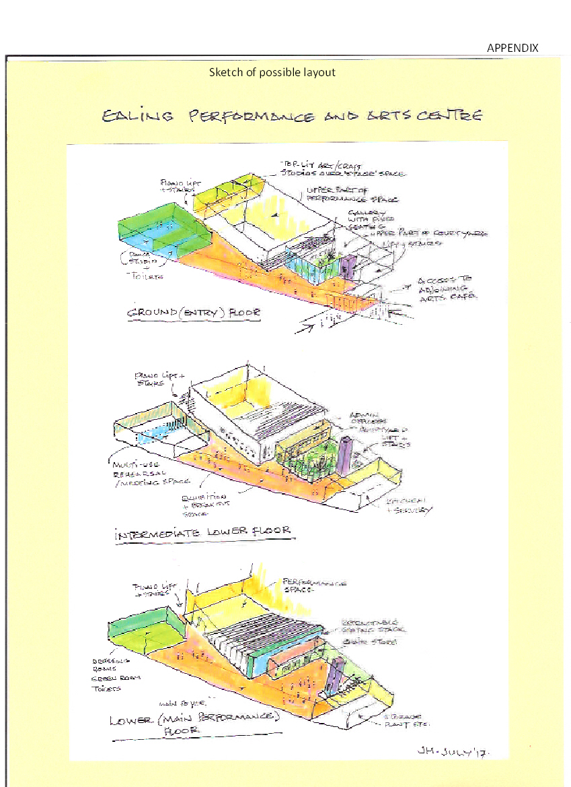

31 Oct 17

Ealing Arts Centre, company limited by guarantee, incorporated in England & Wales No. 7316497
HMRC Charity No. XT39308
www.CEPAC.org.uk
Arts Provision In Ealing Borough Scrutiny Review Panel – 2011/2012 Draft Final Report 28 March 2012 http://ealing.cmis.uk.com/Ealing/Document.ashx?czJKcaeAi5tUFL1DTL2UE4zNRBcoShgo=wn6G639vaaoG4l4PBkRpyI9F8LCFaYVg6Nx76FXeRK%2fnaYkMstBPcA%3d%3d&rUzwRPf%2bZ3zd4E7Ikn8Lyw%3d%3d=pwRE6AGJFLDNlh225F5QMaQWCtPHwdhUfCZ%2fLUQzgA2uL5jNRG4jdQ%3d%3d&mCTIbCubSFfXsDGW9IXnlg%3d%3d=hFflUdN3100%3d&kCx1AnS9%2fpWZQ40DXFvdEw%3d%3d=hFflUdN3100%3d&uJovDxwdjMPoYv%2bAJvYtyA%3d%3d=ctNJFf55vVA%3d&FgPlIEJYlotS%2bYGoBi5olA%3d%3d=NHdURQburHA%3d&d9Qjj0ag1Pd993jsyOJqFvmyB7X0CSQK=ctNJFf55vVA%3d&WGewmoAfeNR9xqBux0r1Q8Za60lavYmz=ctNJFf55vVA%3d&WGewmoAfeNQ16B2MHuCpMRKZMwaG1PaO=ctNJFf55vVA%3d.

